The TurpinTyme Ragsters
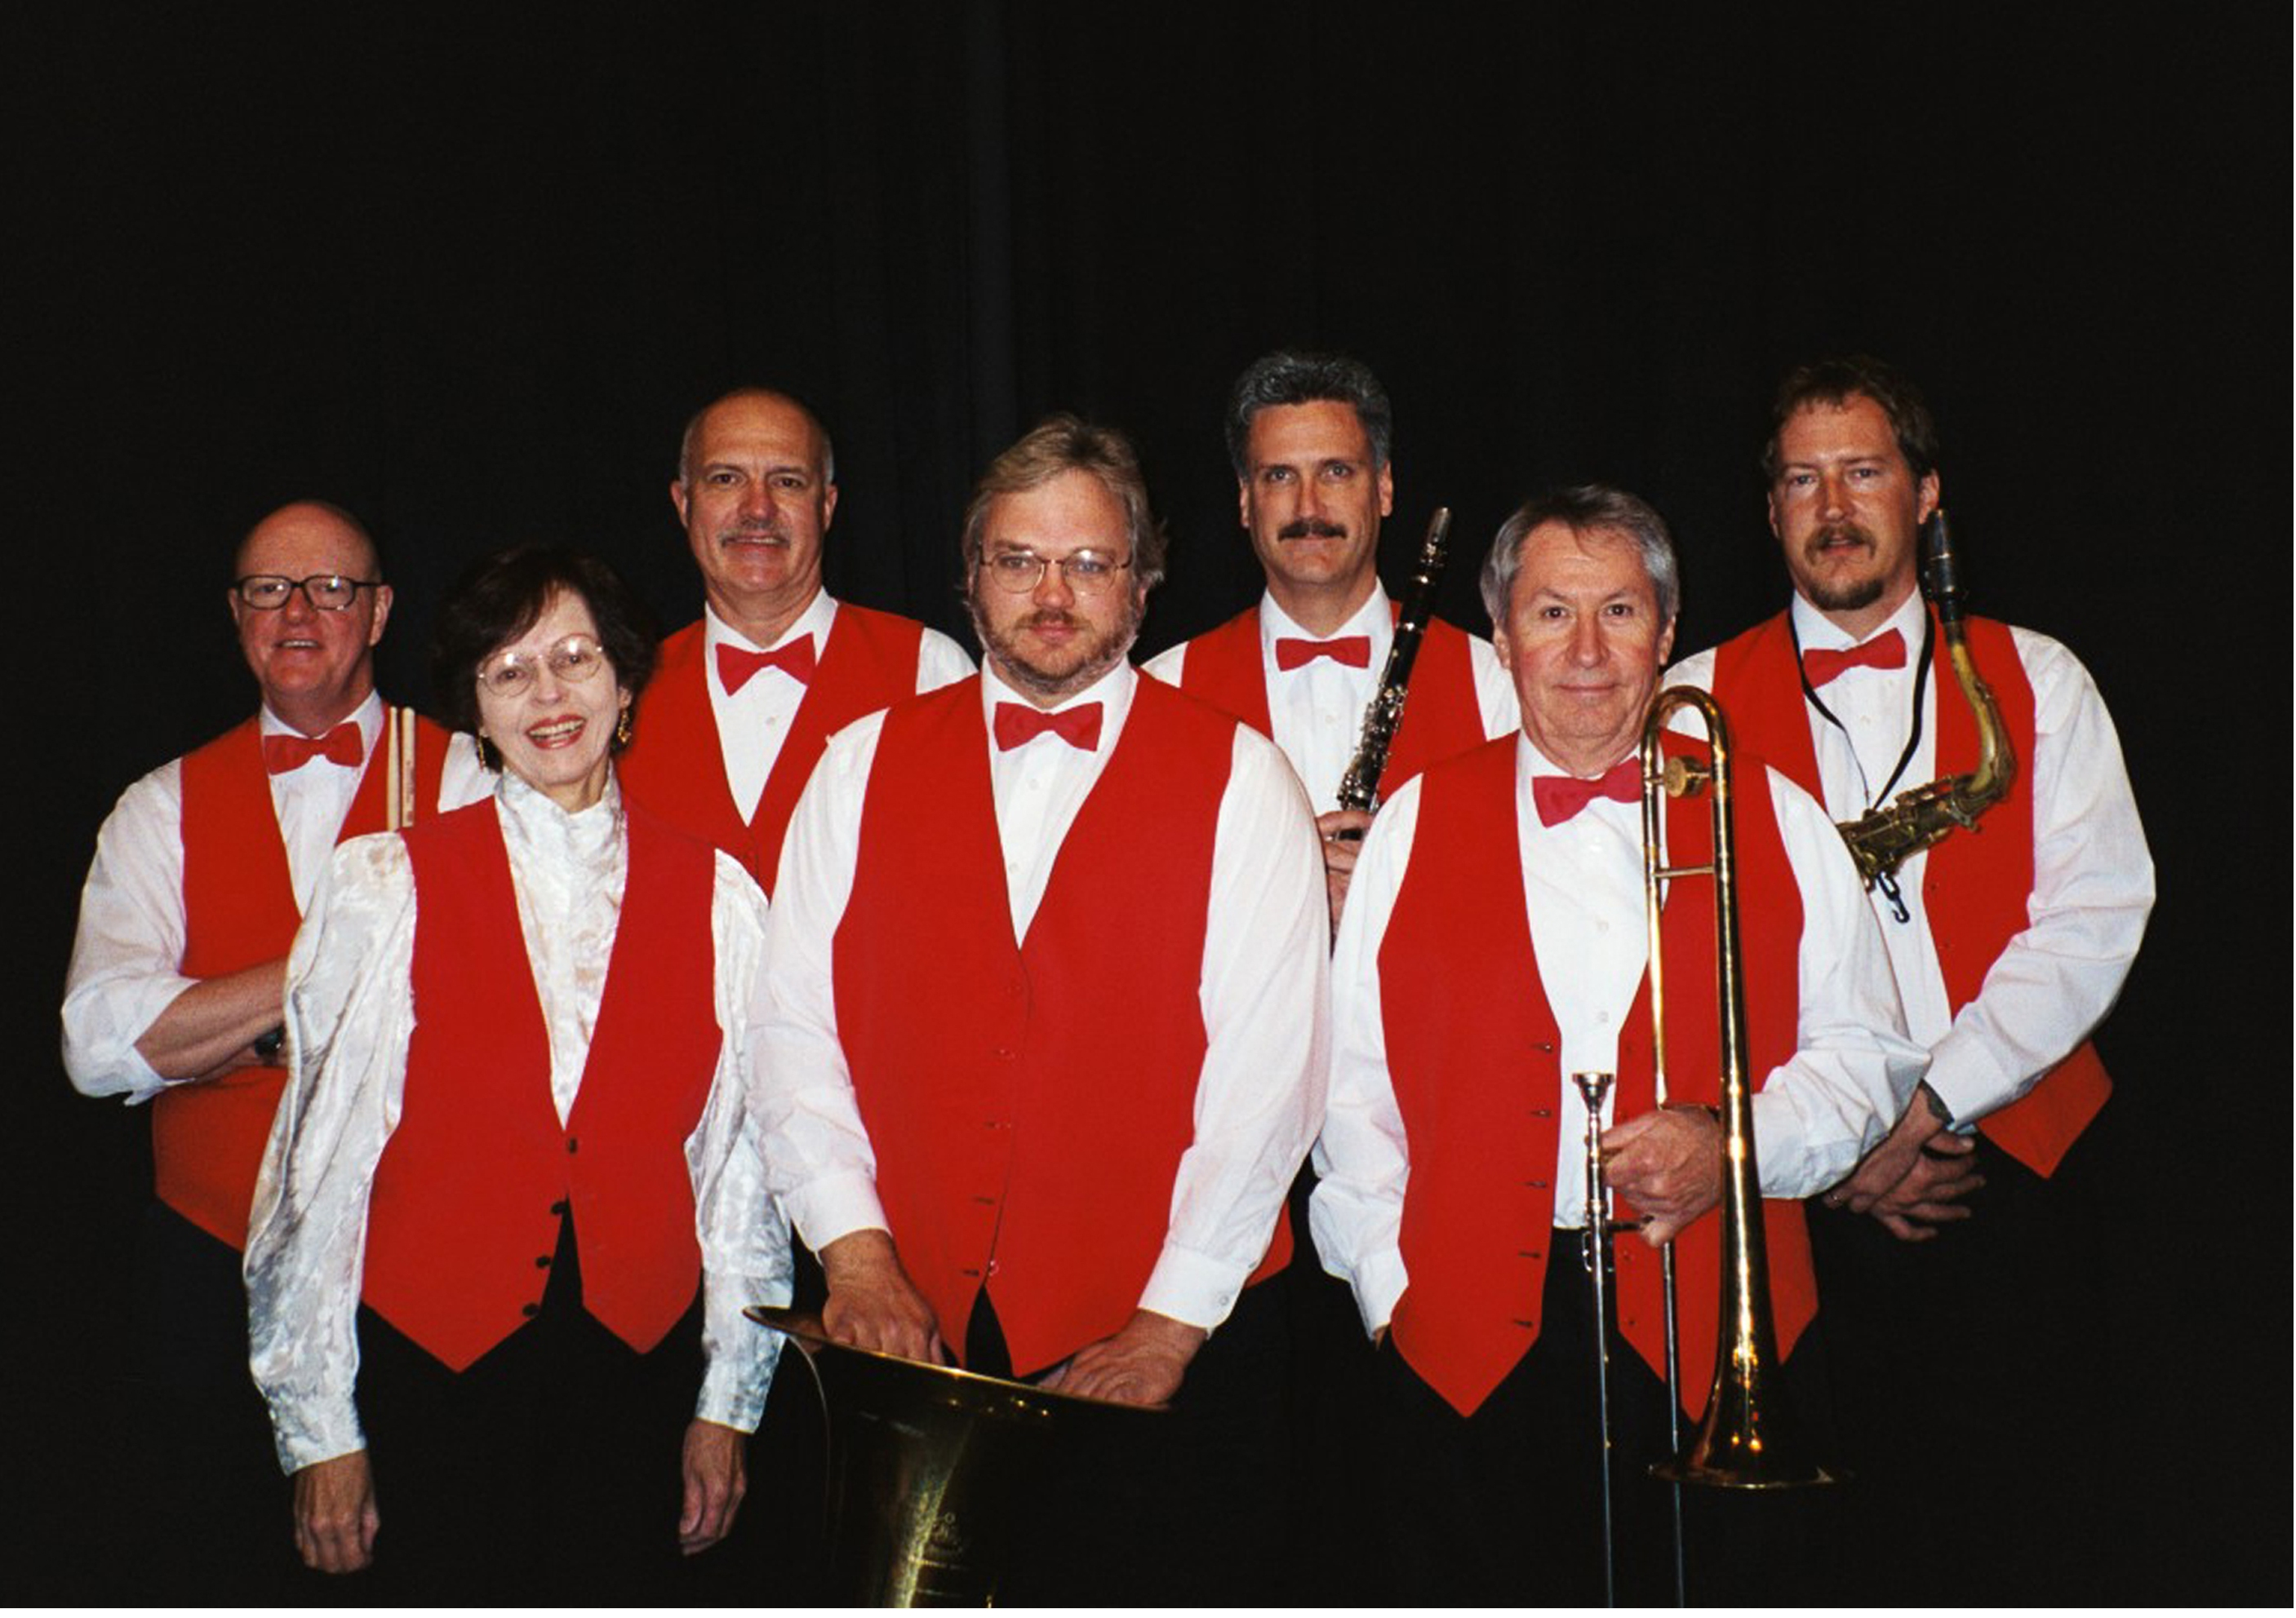
Take you back to an era of ceiling fans, summers on the boardwalk, and of Sunday concerts in the park.

Back to a time when melody was the most important criterion and Ragtime rhythms were the rage!

Our repertoire reflects the diversity of music from "Turn of the Century" America, including composers Scott Joplin, Eubie Blake, and Tom Turpin along with many others.

We hope to give you a few "Pleasant Moments"
and keep your feet tapping to our
Syncopated Rhythms.

